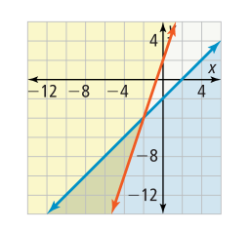
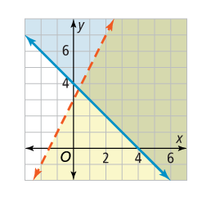
What system of inequalities is shown by the graph?
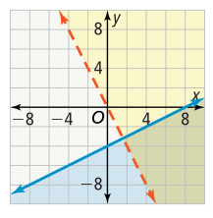
a. b. c.

What system of inequalities is shown by the graph?
a. b. c.

What system of inequalities is shown by the graph?
a. b. c.

