Solve by completing the square

1.  2.  3. 

Put into vertex form and identify the vertex by completing the square

4.  5.  6. 

Simplify

7.  8.  9. 

Solve by factoring

10.  11.  12. 

Solve using the quadratic formula

13.  14. 

Solve

15.  16.  17. 

18. What is the value of x in the picture? 19. What is the discriminant of ?

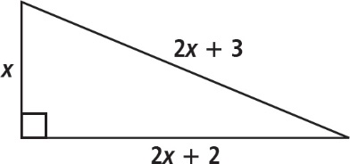 20. If the discriminant is 0, how many solutions are there?

21. The area of a rubber coating for a flat roof is 96 feet squared  
 The rectangular frame the carpenter built has a length that is 4   
 feet greater than the width. Draw a picture of the roof and find   
 the dimensions of the frame.

22. A rectangle with sides measuring x inches and 4x-1 inches has an area of 663 inches squared. What are the dimensions of the rectangle?

23. Veronica shoots a basketball through the air in an attempt to score two points. The height of the ball *h* in feet as a function of the distance *d* in feet that the ball travels horizontally is given by . How far from Veronica will the ball land on the ground if it does not hit the backboard or the rim basket (aka an airball)?

Solve by completing the square

1.  2.  3. 

Put into vertex form and identify the vertex by completing the square

4.  5.  6. 

Simplify

7.  8.  9. 

Solve by factoring

10.  11.  12. 

Solve using the quadratic formula

13.  14. 

Solve

15.  16.  17. 

18. What is the value of x in the picture? 19. What is the discriminant of ?

 20. If the discriminant is 0, how many solutions are there?

21. The area of a rubber coating for a flat roof is 96 feet squared  
 The rectangular frame the carpenter built has a length that is 4   
 feet greater than the width. Draw a picture of the roof and find   
 the dimensions of the frame.

22. A rectangle with sides measuring x inches and 4x-1 inches has an area of 663 inches squared. What are the dimensions of the rectangle?

23. Veronica shoots a basketball through the air in an attempt to score two points. The height of the ball *h* in feet as a function of the distance *d* in feet that the ball travels horizontally is given by . How far from Veronica will the ball land on the ground if it does not hit the backboard or the rim basket (aka an airball)?