AAT Work with different angles

Sketch the following angles

1.  2.  3.  4. 

5. Bearing of  6. Bearing of  7. Bearing of  8. Bearing of 

Use the law of sines to solve the following word problems.

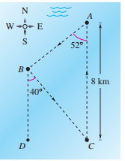9. 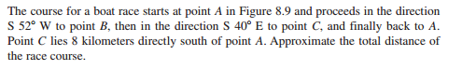

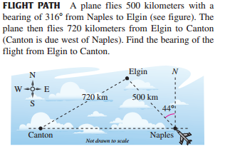10.

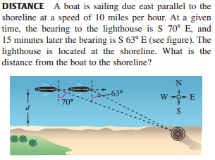11.

AAT Work with different angles

Sketch the following angles

1.  2.  3.  4. 

5. Bearing of  6. Bearing of  7. Bearing of  8. Bearing of 

Use the law of sines to solve the following word problems.

9. 

10.

11. 