Algebra 1 Name: _____________________________

Solve for  using the zero-product property.

1.  2.  3.  4. 

Solve for.

5.  6.  7.  8. 

Simplify the following. Make sure all radicals are completely simplified.

9.  10.  11.  12. 

13.  14. 



Write the factored form of the equation.

15. 16.

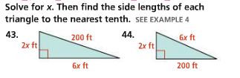17. 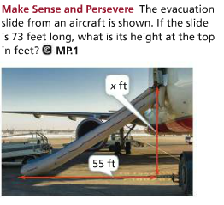 18.

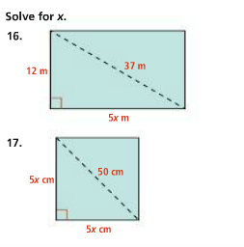 19.

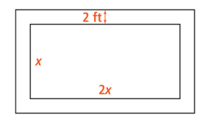

20. The pool has a width

that is twice its length. The

deck surrounding the pool is

2 feet wide. The total area of

the pool is 96 feet squared.   
What are the dimensions of

the pool?

Algebra 1 Name: _____________________________

Solve for  using the zero-product property.

1.  2.  3.  4. 

Solve for.

5.  6.  7.  8. 

Simplify the following. Make sure all radicals are completely simplified.

9.  10.  11.  12. 

13.  14. 



Write the factored form of the equation.

15. 16.

17.  18.

 19.



20. The pool has a width

that is twice its length. The

deck surrounding the pool is

2 feet wide. The total area of

the pool is 96 feet squared.   
What are the dimensions of

the pool?