**4-6 and 4-7 Review**

Class Copy

**Find the exact value of each expression, if it exists.**

**1.**  **2.**  **3.** tan **4.**

**5.** arctan **6.** arcsin **7.** tan **8.** sin

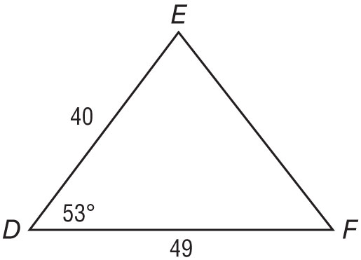**Solve each triangle. Round to the nearest tenth if necessary.**

40

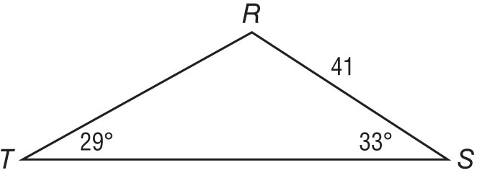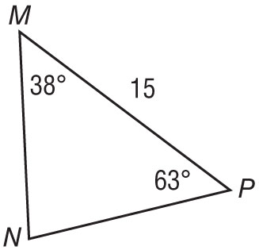**9. 10. 11.**

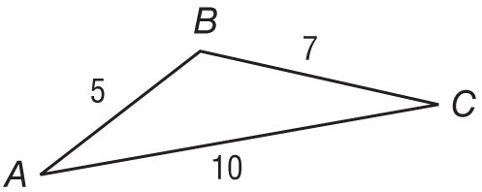

**12.**

**Find all solutions for the given triangle, if possible. Round to the nearest tenth if necessary.**

**13.  14.  15. **

**16. A boat leaves a dock and travels north of west averaging 30 knots for 2 hours. The boat then travels directly west averaging 40 knots for 3 hours.**

1. **How many nautical miles is the boat from the dock after 5 hours?**
2. **How many degrees south of east is the dock from the boat’s present position?**

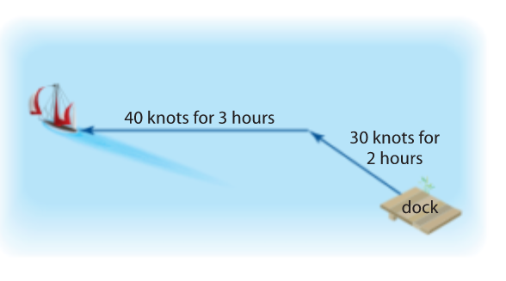

**Find the area of the triangle.**

**17.  18.  19. **

**4-6 and 4-7 Review**

Class Copy

**Find the exact value of each expression, if it exists.**

**1. $\arcsin^{-1}$ $\left(-\frac{\sqrt{3}}{2}\right)$**  **2. $\cos^{-1}$ $\left(cos \frac{π}{3}\right)$**  **3.** tan $\left(-\frac{3π}{2}\right)$**4. $\sin^{-1}$ $\left(cos \frac{π}{3}\right)$**

**5.** arctan $\left(-\frac{\sqrt{3}}{3}\right)$**6.** arcsin $\left(-\frac{1}{2}\right)$**7.** tan $\left(\sin^{-1} 1 - \cos^{-1} \frac{1}{2}\right)$**8.** sin $\left(arctan -\frac{\sqrt{3}}{3}\right)$

**Solve each triangle. Round to the nearest tenth if necessary.**

40

**9. 10. 11.**



**12.**

**Find all solutions for the given triangle, if possible. Round to the nearest tenth if necessary.**

**13.  14.  15. **

**16. A boat leaves a dock and travels north of west averaging 30 knots for 2 hours. The boat then travels directly west averaging 40 knots for 3 hours.**

1. **How many nautical miles is the boat from the dock after 5 hours?**
2. **How many degrees south of east is the dock from the boat’s present position?**



**Find the area of the triangle.**

**17.  18.  19. **