**4-4 and 4-5 Additional Practice**

**1.** Match each inequality with its graph.

*y* < 2*x* − 1

*y* > −*x* + 3

*y* ≥ 2*x* – 1

*y* ≤ −*x* + 3



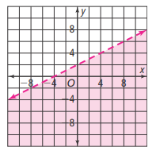**Graph the inequality in the coordinate plane.**

**2.** *y* < *x*

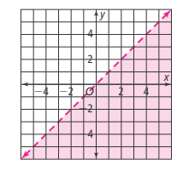

**3.** *y* ≤ 3*x* −6

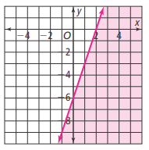

**4.** *x* − 2*y* > −4

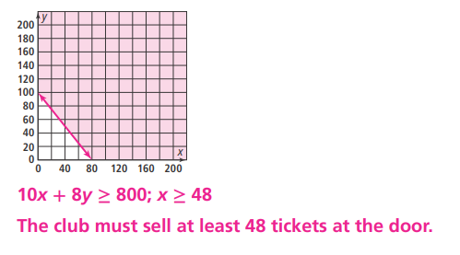**5.**

|  |  |  |  |  |  |
| --- | --- | --- | --- | --- | --- |
| **6.** Graph *y* > 2*x* + 2 and *y* ≤ 2*x* − 5. | **Use the concept list to complete the statements.**   |  |  | | --- | --- | | **above the line** | ***y* ≤ 2x −5** | | ***y* > 2*x* + 2** | **below the line** |   **7.** The graph of _______________ is shaded _________________.  **8.** The graph of _______________ is shaded _________________.  **9.** What is the solution of the system of inequalities |

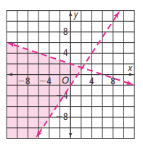**Graph each system of inequalities. Shade the solution of each system.**

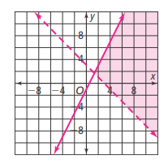**10.** 

**11.** 

**12.** 

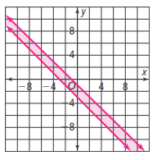

**The solution of what system of inequalities is shown by each graph?**

****13.**

**14.**

**15.**

**16.** 