1-3 Practice Classwork: Continuity, End Behavior, and Limits

Determine whether each function is continuous at the given x-value(s). Justify using the continuity test. If discontinuous, identify the type of discontinuity as infinite, jump, or removable.
1. f(x) = $-\frac{2}{{3x}^{2}}$; at x = –1 2. f(x) = $\frac{x -2}{x + 4}$; at x = –4
3. f(x) = $x^{3}$ – 2x + 2; at x = 1 4. f(x) = $\frac{x + 1}{x^{2} + 3x + 2}$; at x = –1 and x = –2

Determine between which consecutive integers the real zeros of each function are located on the given interval.

5. f(x) = $x^{3}$ + 5$x^{2}$ – 4; [–6, 2] 6. g(x) = $x^{4}$ + 10x – 6; [–3, 2]
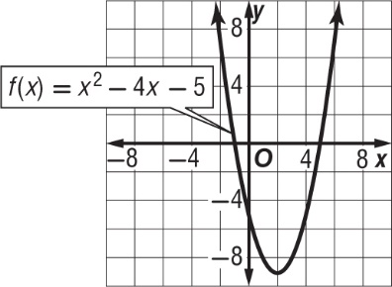
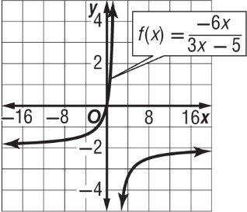
Use the graph of each function to describe its end behavior. Support the conjecture numerically.
7. 8.

9. ELECTRONICS Ohm’s Law gives the relationship between resistance R, voltage E, and current
I in a circuit as R = $\frac{E}{I}$ . If the voltage remains constant but the current keeps increasing in the circuit, what happens to the resistance?
1-3 Practice Classwork: Continuity, End Behavior, and Limits

Determine whether each function is continuous at the given x-value(s). Justify using the continuity test. If discontinuous, identify the type of discontinuity as infinite, jump, or removable.
1. f(x) = $-\frac{2}{{3x}^{2}}$; at x = –1 2. f(x) = $\frac{x -2}{x + 4}$; at x = –4
3. f(x) = $x^{3}$ – 2x + 2; at x = 1 4. f(x) = $\frac{x + 1}{x^{2} + 3x + 2}$; at x = –1 and x = –2

Determine between which consecutive integers the real zeros of each function are located on the given interval.

5. f(x) = $x^{3}$ + 5$x^{2}$ – 4; [–6, 2] 6. g(x) = $x^{4}$ + 10x – 6; [–3, 2]
Use the graph of each function to describe its end behavior. Support the conjecture numerically.
7. 8.

9. ELECTRONICS Ohm’s Law gives the relationship between resistance R, voltage E, and current
I in a circuit as R = $\frac{E}{I}$ . If the voltage remains constant but the current keeps increasing in the circuit, what happens to the resistance?

