Week of April 6th Review

**4-3 Unit Circle**

Find the exact value.

1.  2.  3.  4.  5. 

6.  7.  8. 

**5-4 Sum & Difference Identities**

Find the exact value of each trigonometric expression using the sum difference identities.

1.  2.  3. 

4.  5.  6. 

**1-2 Even/Odd Functions & 5-1 Even-Odd Identities**

Algebraically determine if the following functions are even, odd or neither.

1.  2.  3.  4. 

Solve the following using Even-Odd Identities

5.  6.  7.  8.

**1-3 Limits** *Review on next page if you need a refresher

Use the graph of each function to describe its end behavior using limit notation. Support the conjecture numerically.

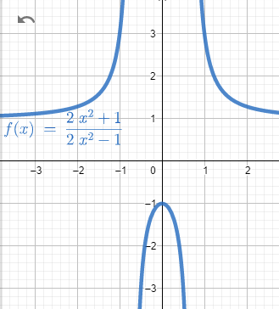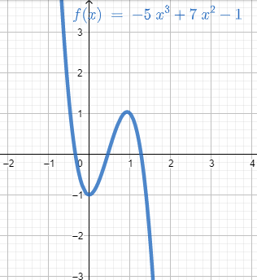1. 2.

Determine if each function is continuous at the given x-value. If discontinuous, identify the type.

3.  4. 

## Review

|  |  |
| --- | --- |
| Recall key terminology | |
| **Continuous function** | *A function that has no breaks, holes, or gaps*. You can trace the graph of a continuous function without lifting your pencil. |
| **Limit** | *The concept of approaching a value without ever reaching.*  Limits can approach from the left (negative side), the right (positive side), or when not specified, from both. |
| **Discontinuity** | *If a graph or function is not continuous (i.e. is discontinuous) at a point, that point is called a discontinuity.*  Types of discontinuities – *Infinite*, *Jump*, *Removable*. |
| **End Behavior** | *What a function does as it approaches positive and negative infinity.* |

|  |  |
| --- | --- |
| Recall key notation | |
| $$\lim_{x→∞}{f(x)}$$ | *Limit of* ***f(x)*** *as* ***x*** *approaches infinity.* |
| $\lim_{x→3^{+}}{f\left(x\right)}$**, $\lim_{x→3^{-}}{f\left(x\right)}$** | *Limit of* ***f(x)*** *as* ***x*** *approaches 3* (note: any number would work here)*. As it approaches that value from the positive and negative directions.* |