Chapter 5 Exponential and Logarithmic Topics:

* Properties of logs
* Natural log *e*
* Compound/continuous interest
* Solving exponential problems
* Investments

1. Use the one to one property to solve

a.  b. 

2. Write the logarithmic equation  in exponential form.

3. Write the exponential equation  in logarithmic form.

4. Solve the following using logarithms

a.  b.  c.  d. 

5. Condense the following expressions

a.  b. 

6. Completely expand into multiple logs with no exponents.

a.  b. 

7. An initial investment of $10,000 triples in 18 years. Assuming the interest is compounded continuously, what was the interest rate of the investment?

8. An initial investment of $5,000 grows at an annual rate of 7% compounded continuously. How long will it take to double the investment?

Chapter 6 Trigonometry Topics:

* Coterminal angles
* Unit Circle
* Inverse Trig functions
* All 6 trigonometric functions
* Converting degrees/radians
* Right triangle trig
* Arc length and area of a sector
* Reference angles

2. Determine the quadrant that lies in if

a. and  b. and 

3. Evaluate

a.  b. 

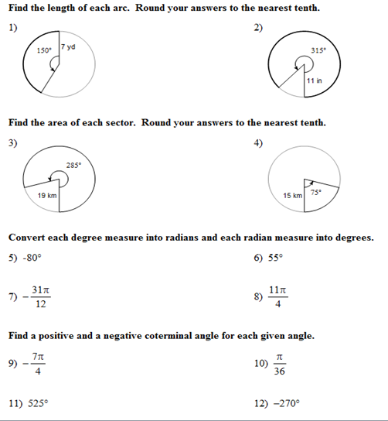

13. What quadrant would the angle  lie in? 14. What quadrant would the angle  lie in?

Give an exact value.

15.  16.  17.  18. 

Chapter 8 Additional Trigonometry Topics:

* Law of Sines
* Law of Cosines
* Ambiguous Case
* Types of angles
* Area of triangles (Heron’s formula, Oblique triangle formula)

1. Determine the area of a triangle having the following measurements. 

2. The sides a, b, c ofhave lengths of 9.3 units, 4.2 units and 6.5 units, respectively. Find the largest angle.

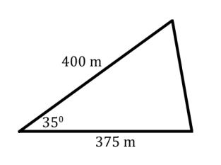3. Determine the area of the triangle having the following side lengths, 13m, 6m and 10m.

4. Find the missing side length in

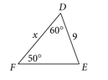5. Solve for x in

6. Given **** find the possible measurement(s) for angle B.

Chapter 9 Systems of Equations and Inequalities

* Solving systems of 2 linear equations
* System of linear & quadratic equations
* System of 3 equations using back substitution
* Writing word problems into systems of equations
* Graphing inequalities
* Finding feasible regions

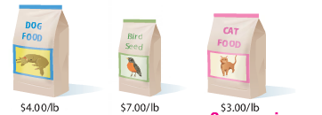1. Amelia purchased 25 total pounds of dog food, bird seed, and cat food for $100. She purchased 10 pounds more dog food than bird seed. The cost per pound of each type of food is shown.

1. Define your variables and write a set of linear equations for this situation.
2. Determine the number of pounds of each type of food Amelia purchased.

2. Solve the system of equations.

 a.  b.  c.  d.

3. Graph 

Chapter 10 Matrices

* Order of matrices
* Operations with matrices
* Putting systems of equations into matrix equations
* Solving matrices using the graphing calculator

1. Solve the following system using matrices.

a.  b. 

2. Ifandfind**