Answers:
Q1. Your values might vary slightly depending on your rounding.
Iteration | Input (Percent Sick) | Output (percent Sick)
1 | 0.04 | 0.0576
2 | 0.0576 | 0.08142
3 | 0.08142 | 0.11219
4 | 0.11219 | 0.14941
5 | 0.14941 | 0.19063
6 | 0.19063 | 0.23143
7 | 0.23143 | 0.26681
8 | 0.26681 | 0.29343
9 | 0.29343 | 0.31099
10 | 0.31099 | 0.32142

Q2. 0.190625313*600 = 114.375
114 people are sick
Q3. The initial growth is concave up, but it then slows and the values appear to be stabilizing at around 1/3 (0.333 of the population or 200 people) getting sick.

Q4.
x = 1.5x(1− x)
x = 1.5x −1.5x²
0 = 0.5x −1.5x²
0 = x(0.5 −1.5x)
x = 0 or 0.5 −1.5x = 0
0.5 = 1.5x
x = $\frac{0.5}{1.5}$

x = $\frac{1}{3}$

Q.5 The values in both cases approach the intersection between the parabola and the line y = x.
Stabilization is at 0.6 or 360 people getting sick.

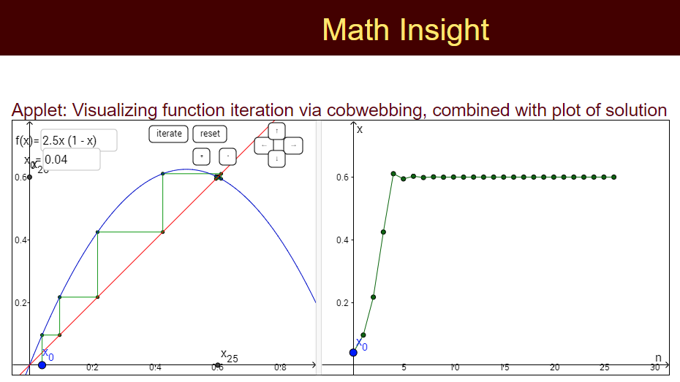

x = 2.5x(1− x)
x = 2.5x −2.5x²
0 = 1.5x −2.5x²
0 = x(1.5 −2.5x)
x = 0 or 1.5 −2.5x = 0
1.5 = 2.5x
x = $\frac{1.5}{2.5}$

x = $\frac{3}{5}$

