Variable Growth Rate Modeling Activity
We will examine a model that assumes growth rate decreases as population size increases.

The Model
We will use x to represent the proportion of the population that is currently sick. In this case, x = 1 represents a population with 100% of the population sick, and 0 < x <1 represents a population with both sick and healthy individuals.
- x(t +1) = proportion of infected people at time t +1
- x(t), the proportion of people currently infected;
- (1− x(t )), the proportion of people not infected;
- r, a growth factor that takes into account both the likelihood of interaction between people and the harmfulness of the disease.

To get a sense of how the dynamic plays out, we’ll create a table, by hand, with the first 10 iterates (or steps) with a population of 600 people and 24 people sick initially.
x(0) = $\frac{600}{24}=$0.04 , r = 1.5 .

x(t +1) = rx(t )(1− x(t ))
x(1) = 1.5(0.04)(1-0.04)
x(1) = 0.0576 (The % of people infected after 1 day (or 1 iteration)
x(2) = 1.5(0.0576)(1-0.0576) = 0.08142

Q1. Use a calculator or Excel spreadsheet (instructions below) to fill the values in the table. Remember that the output from one step becomes the input for the next step.

Iteration | Input (Percent Sick) | Output (percent Sick)
1 | 0.04 | 0.0576
2 | 0.0576 | 0.08142
3 | 0.08142
4
5
6
7
8
9
10

Using Excel to calculate percentage of sick people

Open new spreadsheet
Click on cell A1 and type in 0.04
Click on cell A2 and type in =1.5*(A1)*(1-A1) then press ‘Enter’
Click on cell A2 again and copy cell by pressing ‘Ctrl + c’
Click on cell A3, hold ‘Shift’ key down and at the same time use down arrow key to highlight cells through A20
Press ‘Ctrl + v’ and you should see the screen below:

Q2. What proportion of the population is sick after the 5th iteration?
How many students is this?

Graphing model using online tool
Now create an Input-Output plot using online graphing tool.

1) Go to http://mathinsight.org/applet/function_iteration_cobweb_combined
2) For f(x) type in 1.5(x)(1-x)
3) For x₀ type in 0.04
4) Re-size window using the + and the arrow keys so each axis goes 0 to 0.6 or 0.8.
5) Click on the ‘Iterate’ button to generate plots.
7) Press reset for new graph using x₀= 0.5

The left panel shows the input-output while the right panel shows a plot of the results against the iteration number. The red line is the diagonal and the point where our graph intersects the diagonal is the equilibrium or where the iteration reaches stabilization.

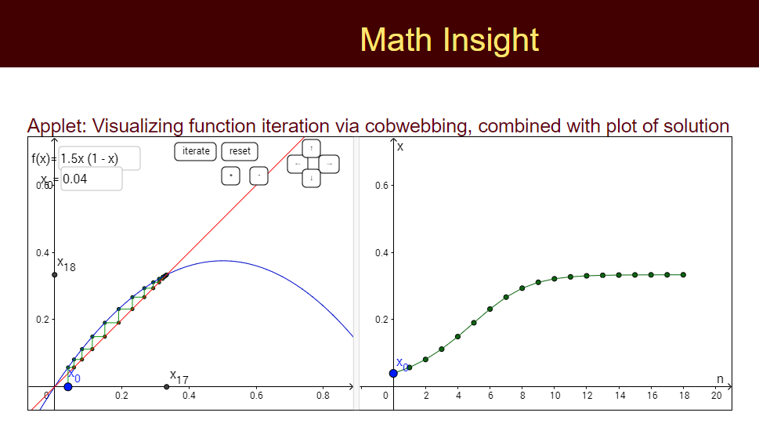
y= 1.5x(1-x)
y=x

Q3. Describe what is happening to the graphs. Are they stabilizing? If so, at what value?

Q4. How would you solve for the stabilization point (intersection of 2 graphs) algebraically?

Q5. What happens if we have a disease with a higher r value, indicating a greater likelihood of transmission? Use r value of 2.5 in the graphing tool: f(x)=2.5(x)(1-x)
What is the stabilization point?

