Chapter 9 review

Solve the following using any method you like:  
1.  2.  3. 

4.  5.  6. 

7.  8.  9. 

10. You set up a scrapbook business and make an initial investment of $50,000. The unit cost of a scrapbook kit is $12 and the selling price is $25. How many kits must you sell to break even?

11. Sketch the graph and label the vertices of the feasible region.

a.  b. 

12. Sketch the region determined by the constraints. Then find the minimum and maximum values of the objective function.

Objective function:  Constraints: 

13. For the following problems define your variables and write constraints and find the profit equation. Don’t solve

a. A new clothing company wants to make shorts and tank tops. Each pair of shorts nets the company $12.00 in profit and each tank top nets the company $8.00 in profit. Both shorts and take tops require sewing and cutting.

Shorts take 2 hours to cut and tank tops take 1.5 hours to cut out. The cutting machine is available 25 hours per  
week.

Shorts take 4 hours to sew and tank tops take 3 hours to sew. The sewing machine is available 35 hours per week.

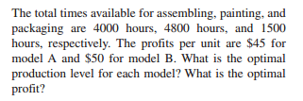b. 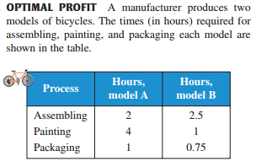Chapter 9 review

Solve the following using any method you like:  
1.  2.  3. 

4.  5.  6. 

7.  8.  9. 

10. You set up a scrapbook business and make an initial investment of $50,000. The unit cost of a scrapbook kit is $12 and the selling price is $25. How many kits must you sell to break even?

11. Sketch the graph and label the vertices of the feasible region.

a.  b. 

12. Sketch the region determined by the constraints. Then find the minimum and maximum values of the objective function.

Objective function:  Constraints: 

13. For the following problems define your variables and write constraints and find the profit equation. Don’t solve

a. A new clothing company wants to make shorts and tank tops. Each pair of shorts nets the company $12.00 in profit and each tank top nets the company $8.00 in profit. Both shorts and take tops require sewing and cutting.

Shorts take 2 hours to cut and tank tops take 1.5 hours to cut out. The cutting machine is available 25 hours per  
week.

Shorts take 4 hours to sew and tank tops take 3 hours to sew. The sewing machine is available 35 hours per week.

b. 