Chapter 8 Vectors Review:
Topics: identify vector quantities (p.482), represent a vector geometrically (p.483), find the resultant of two vectors (p. 434), operations with vectors (p.485), rectangular components of vectors (p. 487), express a vector in component form (p.492, p.495), find direction angle (p.496), magnitude of vectors (p.493), operations with vectors using components (p. 493), find a unit vector with the same direction as a given vector (p.494), write a vector as a linear combination of unit vectors (p. 495), vector application problems (p.486, p.496)
1. | State whether each quantity is a vector quantity:  - a car driving 50 mph due east Answer: VECTOR  - a gust of wind blowing 5 mph Answer: SCALAR  - walking 4km east of west Answer:VECTOR  - pushing down on an object with 7 Newtons of force Answer:VECTOR | 2. | Use a ruler and a protractor to draw an arrow diagram for v = 10 newtons of force at 30° to the horizontal. Include a scale on the diagram.  Answer: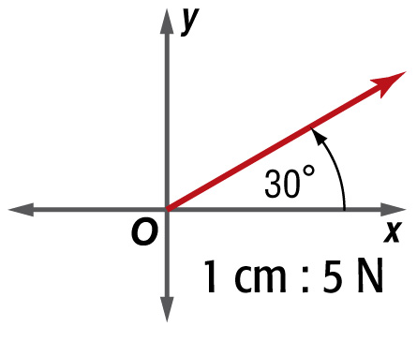  V
3. | Find the resultant of:  Vector 1: 2 kilometers N30°W  Vector 2: 2 kilometers directly east  Answer: Can use a ruler and protractor or calculate the components of each vector and add them together. 2 kilometers at a bearing of 30° east of north or N30°E | 4. |  | An airplane is flying with an airspeed of 475 miles per hour on a heading of 070°. If an 80-mile-per-hour wind is blowing from a true heading of 120°, determine the velocity and direction of the plane relative to the ground.Answer: Can use a ruler and protractor or calculate the components of each vector and add them together. The velocity of the plane relative to the ground is about 428.0 miles per hour at a bearing of about 061.8°
5. | Will pushes a shovel into the ground with a force of 630 newtons at an angle of 70° with the ground. Draw a diagram that shows the vector and its rectangular components. Then calculate the rectangular components.  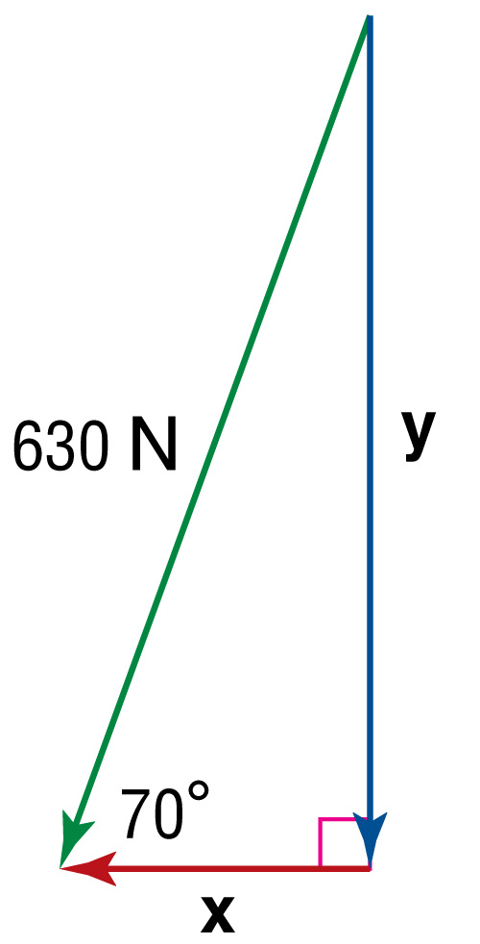  horizontal component ≈ 215.47 Newtons  vertical component ≈ 592.01 Newtons | 6. |  | A. Find the component form of a vector with an initial point A(1, –3) and terminal point B(1, 3)  Answer: <0,6>  B. Find the component form of a vector with an initial point C(–4, –3) and terminal point D(5, 3)  Answer: <9,6>
7. | A. Find the magnitude of a vector with initial point A(1, –3) and terminal point B(1, 3)  Answer: 6  B. Find the magnitude of a vector with initial point C(4, –2) and terminal point D(–3, –2)  Answer: 7 | 8. |  | Find 2w + y for w = ⟨2, –5⟩, y = ⟨2, 0⟩, and  z = ⟨–1, –4⟩.Answer:  ⟨6, –10⟩
9. | A. Find a unit vector u with the same direction as v = ⟨4, –2⟩.  Answer:  B. Find a unit vector u with the same direction as w = ⟨5, –3⟩.  Answer:  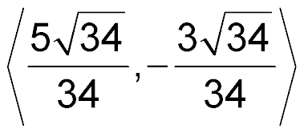 | 10. |  | A. A vector has initial point D(–4, 3) and terminal point E(–1, 5). Rewrite the vector as a linear combination of the vectors i and j.  Answer:  3i + 2j  B. Vector=⟨2, 9⟩ Rewrite the vector as a linear combination of the vectors i and j.  Answer:  2i + 9j
11. | Find the component form of the vector v with magnitude 7 and direction angle 60°.  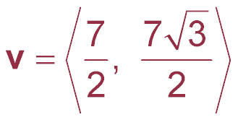 | 12. |  | A. Find the direction angle of r = –7i + 2j to the nearest tenth of a degree.  B. Find the direction angle of p = ⟨2, 9⟩ to the nearest tenth of a degree.
13. | A soccer player running forward at 7 meters per second kicks a soccer ball with a velocity of 30 meters per second at an angle of 10° with the horizontal. What is the resultant speed and direction of the kick?  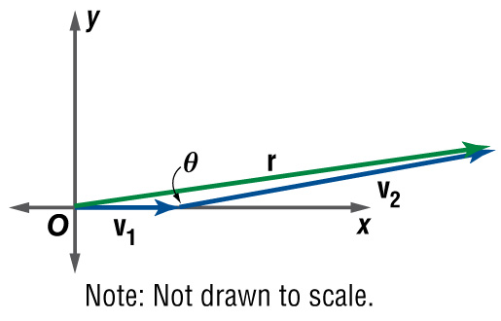  Answer: 36.9 m/s; 8.1°

