Pre Calc 6-2 Word Problem Practice WS

1. What is each student’s final grade?
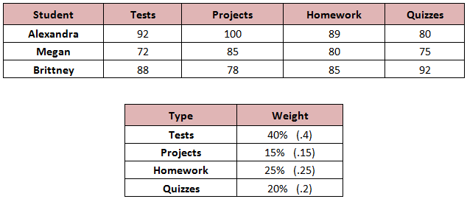

2. What is the Nutrition information for each blend? 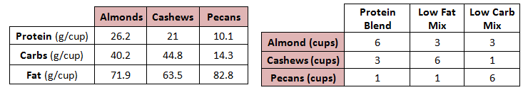

3. If a serving is 1 cup rather than 10 cups, what is the nutrition per serving?

4. The first table below show the points awarded by judges at a state fair for a crafts contest for Brielle, Brynn, and Briana. The second table shows the multiplier used for the degree of difficulty for each of the pieces the girls created. Find the total score for each of the girls in this contest.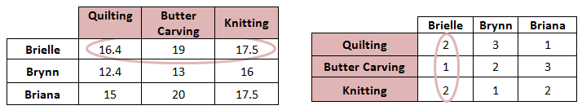
5. | 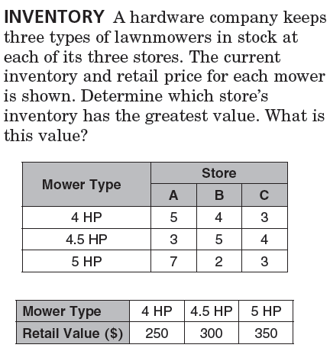 | 6. | 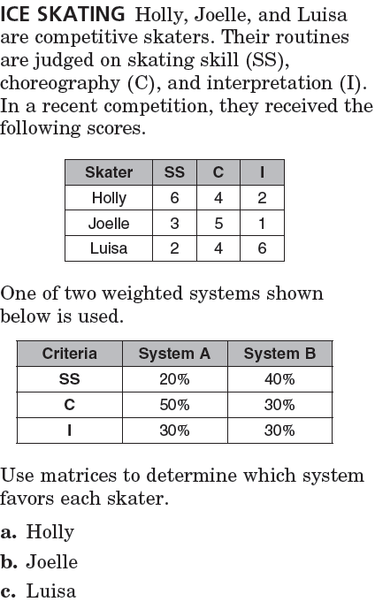

Pre Calc 6-2 Word Problem Practice WS

1. What is each student’s final grade?

2. What is the Nutrition information for each blend?

3. If a serving is 1 cup rather than 10 cups, what is the nutrition per serving?

4. The first table below show the points awarded by judges at a state fair for a crafts contest for Brielle, Brynn, and Briana. The second table shows the multiplier used for the degree of difficulty for each of the pieces the girls created. Find the total score for each of the girls in this contest.
5. |  | 6.

