6.6-6.7 review worksheet

Evaluate the following.

1.  2.  3.  4. 

5.  6.  7.  8. 

Find the exact value of the expressions given below. Include a triangle for all problems as needed.

9.  10.  11.  12. 

13. You lean a ladder 7.3 meters long against a wall. It makes an angle of with the level ground. How high up is the top of the ladder. Include a picture.

14. An observer 5.2 kilometers from the launch pad observes a space ship ascending. At a moment in time the angle of elevation is . How high is the space ship at this moment in time?

15. 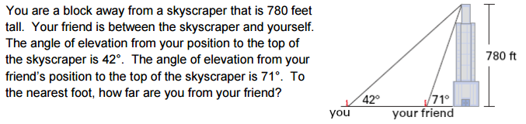

16. A tree casts a shadow that is 21 meters long. The angle of elevation to the sun is . What is the height of the tree?

17. You are flying a kite and have let out 95 meters of string. The kite’s angle of elevation with the ground is . If the string is stretched straight, how high above the ground is the kite?

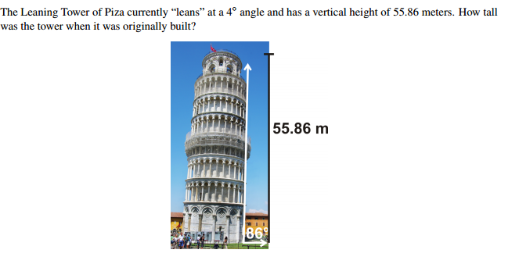18.

6.6-6.7 review worksheet

Evaluate the following.

1.  2.  3.  4. 

5.  6.  7.  8. 

Find the exact value of the expressions given below. Include a triangle for all problems as needed.

9.  10.  11.  12. 

13. You lean a ladder 7.3 meters long against a wall. It makes an angle of with the level ground. How high up is the top of the ladder. Include a picture.

14. An observer 5.2 kilometers from the launch pad observes a space ship ascending. At a moment in time the angle of elevation is . How high is the space ship at this moment in time?

15. 

16. A tree casts a shadow that is 21 meters long. The angle of elevation to the sun is . What is the height of the tree?

17. You are flying a kite and have let out 95 meters of string. The kite’s angle of elevation with the ground is . If the string is stretched straight, how high above the ground is the kite?

18.