1.3-1.4 Quiz Review Classwork Date:_________

**Determine whether each function is continuous at x=-5. Justify your answer using the continuity test.**

1.  2. 

**Determine between which consecutive integers the real zeros of each function are located on the given interval.**

3.  4. 

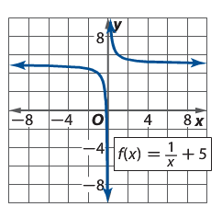**Use the graph of each function to describe its end behavior.**

5. 6.

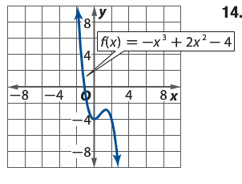

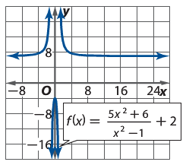  
7.

**Multiple Choice**

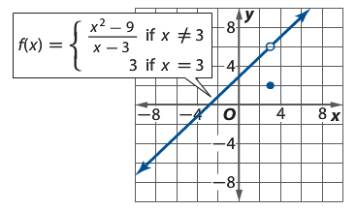8. The graph of  contains a(n)______ discontinuity at 

a) Undefined

b) Infinite

c) Jump

d) Removable

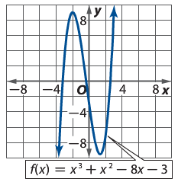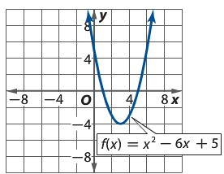**Use the graph of each function to estimate intervals to the nearest 0.5 unit on which the function is increasing, decreasing, or constant.**

9. 10.

11. Using the equations for 9 and 10 find all extrema.

1.3-1.4 Quiz Review Classwork Date:_________

**Determine whether each function is continuous at x=-5. Justify your answer using the continuity test.**

1.  2. 

**Determine between which consecutive integers the real zeros of each function are located on the given interval.**

3.  4. 

**Use the graph of each function to describe its end behavior.**

5. 6.



  
7.

**Multiple Choice**

8. The graph of  contains a(n)______ discontinuity at 

a) Undefined

b) Infinite

c) Jump

d) Removable

**Use the graph of each function to estimate intervals to the nearest 0.5 unit on which the function is increasing, decreasing, or constant.**

9. 10.

11. Using the equations for 9 and 10 find all extrema.