Pre Calc 6-2 Word Problem Practice WS
Rewrite the problems below using matrices and then use matrix multiplication to answer the question being asked.
1. What is each student’s final grade?
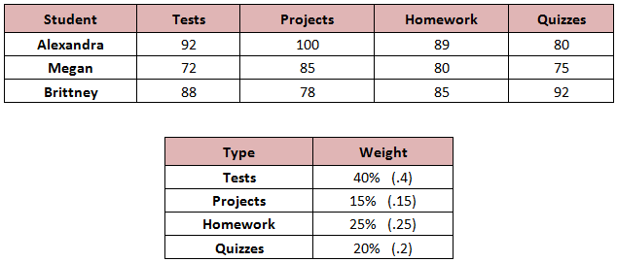

2. What is the Nutrition information for each blend? 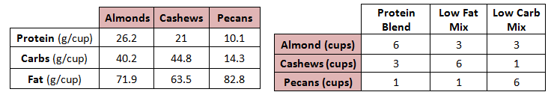

3. | 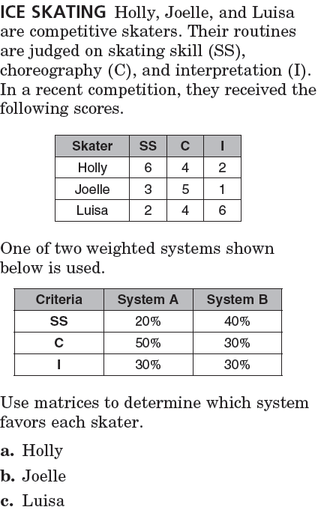
4. The first table below gives the number of three types of cars sold in January by two different dealers. The second table gives the profit for each type of car sold. Using matrix multiplication, which dealer made the most profit in the month of January and by how much?

 | Dealer 1 | Dealer 2
Compact | 18 | 15
Mid-size | 24 | 17
Full-size | 16 | 22

 | Compact | Mid-size | Full-size
Profit | $400 | $650 | $900

