Pre Calc 6-2 Word Problem Practice WS
Answers:

1. What is each student’s final grade?

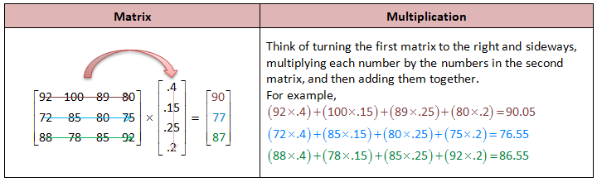
Alexandra has a 90, Megan has a 77, and Brittney has an 87

2.
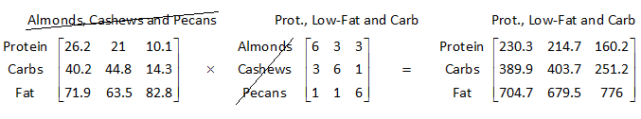

The entire matrix is the answer.
3. Holly- system B, Joelle- system A, Luisa- system A
4. Dealer 1 made $37,200 which is $350 more than Dealer 2 which only made $36,850.

